***\*\*\* PLEASE DOWNLOAD THIS DOCUMENT FROM YOUR WEB BROWSER IF IT HAS NOT DONE SO AUTOMATICALLY \*\*\****

***This layout is made using Microsoft Word. You will be dragging, rotating, and copying objects like***

***beds and flooring. If you are unfamiliar with this, do not worry – we will guide you step-by-step.***

Depending on your settings, you may need to  at the top of your screen in order to change the layout.

***TIPS FOR BEGINNERS***

* **Copy:** Duplicate an object by using **Right-click > Copy** then **Right-click > Paste** or **Ctrl+C** then **Ctrl+V**.
* **Rotate:** Click on the object, then drag the circular arrow above it 
* **Resize:** Click on the object then drag the white corner points with your mouse. Do **NOT** to resize flooring or beds!
* **Bring an object to the foreground:** eg. to put the hoist “on top” of the flooring, **Right Click > Bring to Front**.

***THINGS TO KEEP IN MIND***

* Flooring should continue underneath the bed or chair to allow for the hoist and sling to be positioned over them. Remember, some beds have legs in the middle.
* **Make sure the hoist wheels do not go off the side of the flooring** - Move the hoist around by dragging it with the mouse. Rotate the hoist to simulate travelling from the bed to the wheelchair, or the bed to the bathroom, etc.
* ***Save*** your layout! For example: ‘*Pelican Custom Flooring Plan – Bedroom – Client Name.docx’.* Use the***Save As*** command to make alternate layouts or new rooms, for example: ‘*Pelican Custom Flooring Plan – Lounge – Client Name.docx’*
* You can email your layout to [sales@pelicanmanufacturing.com.au](mailto:sales@pelicanmanufacturing.com.au) | [Visit the Hard Plastic Flooring Webpage](https://www.pelicanmanufacturing.com.au/product/hard-plastic-flooring/)

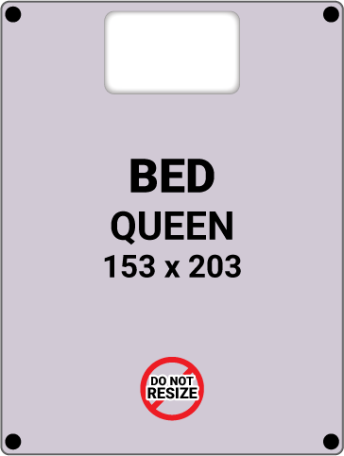

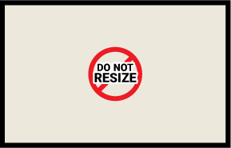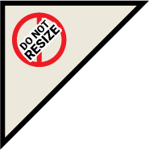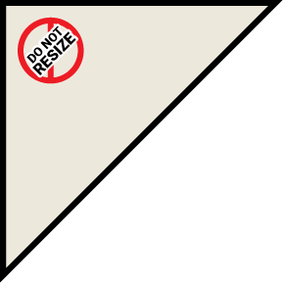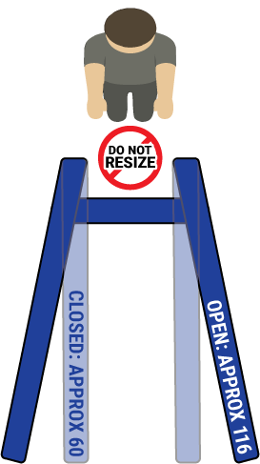

**NOTES:**